***What is mean by Cloud Computing :***

*Simply put, cloud computing is the delivery of computing services—including servers, storage, databases, networking, software, analytics, and intelligence—over the Internet (“the cloud”) to offer faster innovation, flexible resources, and economies of scale. You typically pay only for cloud services you use, helping lower your operating costs, run your infrastructure more efficiently and scale as your business needs change.*

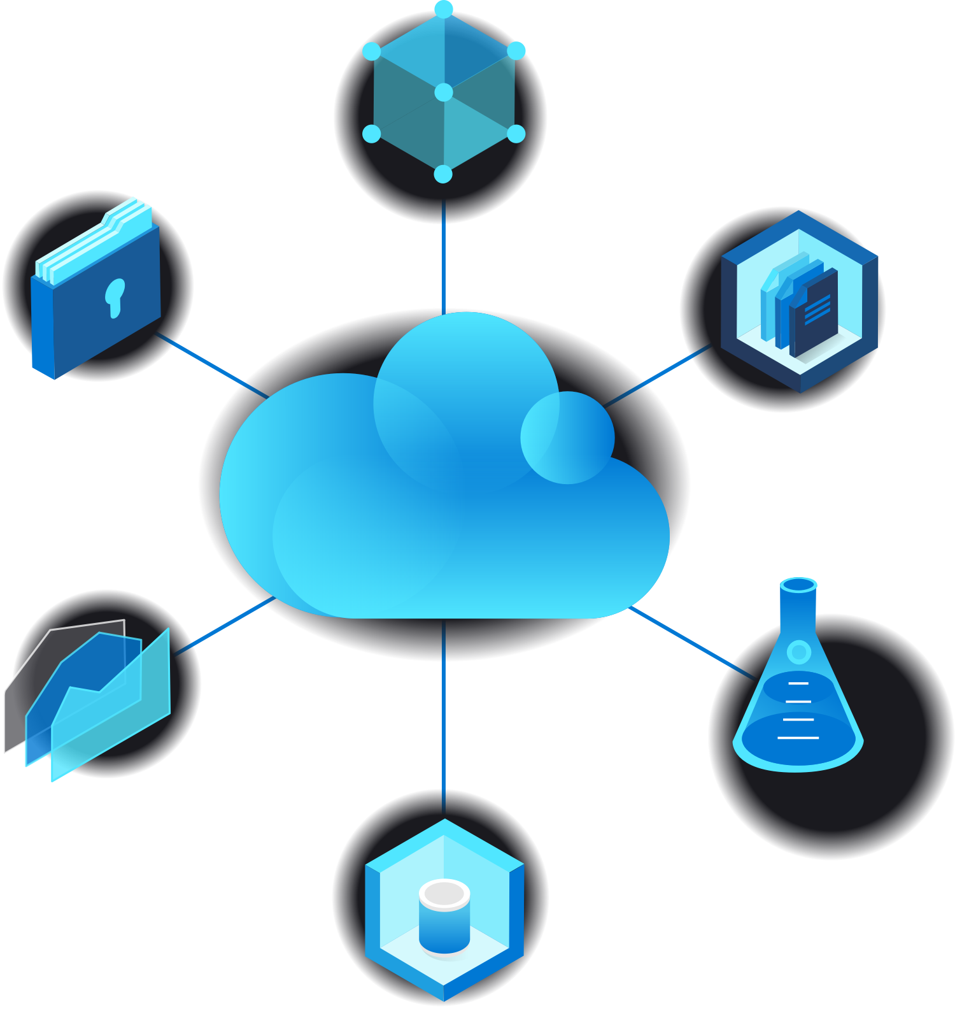



Cloud computing is a big shift from the traditional way businesses think about IT resources. Here are seven common reasons organisations are turning to cloud computing services:

### Cost

Cloud computing eliminates the capital expense of buying hardware and software and setting up and running on-site datacenters—the racks of servers, the round-the-clock electricity for power and cooling, the IT experts for managing the infrastructure. It adds up fast.

### Speed

Most cloud computing services are provided self service and on demand, so even vast amounts of computing resources can be provisioned in minutes, typically with just a few mouse clicks, giving businesses a lot of flexibility and taking the pressure off capacity planning.

### Global scale

The benefits of cloud computing services include the ability to scale elastically. In cloud speak, that means delivering the right amount of IT resources—for example, more or less computing power, storage, bandwidth—right when it is needed and from the right geographic location.

### Productivity

On-site datacenters typically require a lot of “racking and stacking”—hardware setup, software patching, and other time-consuming IT management chores. Cloud computing removes the need for many of these tasks, so IT teams can spend time on achieving more important business goals.

### Performance

The biggest cloud computing services run on a worldwide network of secure datacenters, which are regularly upgraded to the latest generation of fast and efficient computing hardware. This offers several benefits over a single corporate datacenter, including reduced network latency for applications and greater economies of scale.

### Reliability

Cloud computing makes data backup, disaster recovery and business continuity easier and less expensive because data can be mirrored at multiple redundant sites on the cloud provider’s network.

### Security

Many cloud providers offer a broad set of policies, technologies and controls that strengthen your security posture overall, helping protect your data, apps and infrastructure from potential threats.

Types Of Coulds

### Public cloud

Public clouds are owned and operated by a third-party [cloud service providers](https://azure.microsoft.com/en-in/overview/choosing-a-cloud-service-provider/), which deliver their computing resources like servers and storage over the Internet. Microsoft Azure is an example of a public cloud. With a public cloud, all hardware, software and other supporting infrastructure is owned and managed by the cloud provider. You access these services and manage your account using a web browse

### Private cloud

A private cloud refers to cloud computing resources used exclusively by a single business or organisation. A private cloud can be physically located on the company’s on-site datacenter. Some companies also pay third-party service providers to host their private cloud. A private cloud is one in which the services and infrastructure are maintained on a private network

### Hybrid cloud

Hybrid clouds combine public and private clouds, bound together by technology that allows data and applications to be shared between them. By allowing data and applications to move between private and public clouds, a hybrid cloud gives your business greater flexibility, more deployment options and helps optimise your existing infrastructure, security and compliance

## Types of cloud services: IaaS, PaaS, and SaaS

Most cloud computing services fall into four broad categories: infrastructure as a service (IaaS), platform as a service (PaaS), serverless and software as a service (SaaS). These are sometimes called the cloud computing stack because they build on top of one another. Knowing what they are and how they are different makes it easier to accomplish your business goals.

### Infrastructure as a service (IaaS)

The most basic category of cloud computing services. With IaaS, you rent IT infrastructure—servers and virtual machines (VMs), storage, networks, operating systems—from a cloud provider on a pay-as-you-go basis.

### Platform as a service (PaaS) :

Platform as a service refers to cloud computing services that supply an on-demand environment for developing, testing, delivering and managing software applications. PaaS is designed to make it easier for developers to quickly create web or mobile apps, without worrying about setting up or managing the underlying infrastructure of servers, storage, network and databases needed for development.

### Software as a service (SaaS)

Software as a service is a method for delivering software applications over the Internet, on demand and typically on a subscription basis. With SaaS, cloud providers host and manage the software application and underlying infrastructure and handle any maintenance, like software upgrades and security patching. Users connect to the application over the Internet, usually with a web browser on their phone, tablet or PC.

**What is DevOps :**

## How DevOps Works

**Under a DevOps model, development and operations teams are no longer “siloed.” Sometimes, these two teams are merged into a single team where the engineers work across the entire application lifecycle, from development and test to deployment to operations, and develop a range of skills not limited to a single function.**

**In some DevOps models, quality assurance and security teams may also become more tightly integrated with development and operations and throughout the application lifecycle. When security is the focus of everyone on a DevOps team, this is sometimes referred to as DevSecOps.**

**These teams use practices to automate processes that historically have been manual and slow. They use a technology stack and tooling which help them operate and evolve applications quickly and reliably. These tools also help engineers independently accomplish tasks (for example, deploying code or provisioning infrastructure) that normally would have required help from other teams, and this further increases a team’s velocity.**

### Speed

**Move at high velocity so you can innovate for customers faster, adapt to changing markets better, and grow more efficient at driving business results. The DevOps model enables your developers and operations teams to achieve these results. For example, [microservices](https://aws.amazon.com/devops/what-is-devops/" \l "microservices) and**[**continuous delivery**](https://aws.amazon.com/devops/continuous-delivery/)**let teams take ownership of services and then release updates to them quicker.**

### Rapid Delivery

**Increase the frequency and pace of releases so you can innovate and improve your product faster. The quicker you can release new features and fix bugs, the faster you can respond to your customers’ needs and build competitive advantage.**[**Continuous integration**](https://aws.amazon.com/devops/continuous-integration/)**and**[**continuous delivery**](https://aws.amazon.com/devops/continuous-delivery/)**are practices that automate the software release process, from build to deploy.**

### Reliability

**Ensure the quality of application updates and infrastructure changes so you can reliably deliver at a more rapid pace while maintaining a positive experience for end users. Use practices like**[**continuous integration**](https://aws.amazon.com/devops/continuous-integration/)**and**[**continuous delivery**](https://aws.amazon.com/devops/continuous-delivery/)**to test that each change is functional and safe.**[**Monitoring and logging**](https://aws.amazon.com/devops/what-is-devops/#monitoring)**practices help you stay informed of performance in real-time.**